XPath Handling:

* “//a[contains(text(),’value’)]”
* You use “//” – when you use relative path, “/” – When you use absolute or exact path.

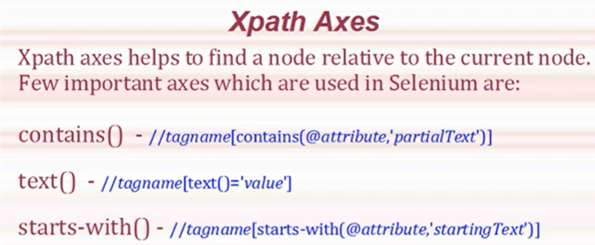

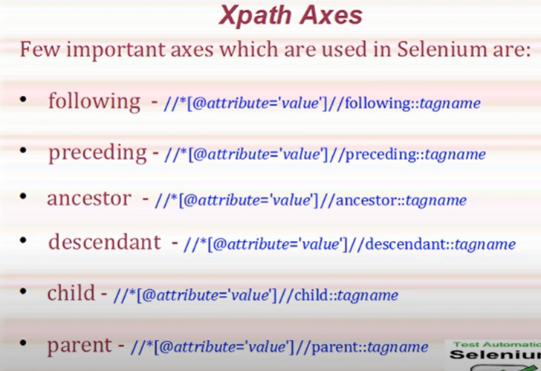

Xpath’s in Orange HRM page:

//span[contains(text(),'Assign Leave')]

//a[contains(text(),'Candidates')]

Xpath’s:

CSS -> Cascading Style Sheets

syntax: tagname#elementID (To locate element using CSS ID)

ex: input#first_name

Ancestor: This refers to above the context node

Descendant : This refers to below (next) the context node.

Inside a tag descendant will be keep traversing inside that tag.

Whereas Child will keep traverse to the next node at the same level

Example of Descendant :

Facebook login page identifying surname

* //div[@id='reg_form_box']/child::div[1]/descendant::input[2]

//tagname[@attribute='value']//preceding::tagname

//tagname[@attribute='value']/following-sibling::tagname

* //input[@id='u_0_6']/ancestor::div[2]//input[@name='reg_email__'] - Facebook login page(using female radio button selecting Email ID)
* //input[@id='u_0_6']//preceding::input[3] - Same as above
* //div[@id='reg_form_box']/child::*
* //div[@id='reg_form_box']/child::div[9]

//ul[@class='unstyled']/a[contains(text(),'Commerce Cloud')]/following-sibling::li

* //h3[contains(text(),'Developer Centers')] - Tried in Salesforce Developers for the footers

//div[@class='footerCols1']//ul[@class='unstyled']//a[contains(text(),'Commerce Cloud')]

//ul[@class='slds-container--fluid']//span[contains(text(),'Global Gatherings')]

//div[contains(text(),'Petrol')]/following-sibling::div[@class = 'gr-home-widget-block-price gr-clearfix']/span

//div[contains(text(),'Nifty')]/following-sibling::div[@class = 'text']

https://www.guru99.com/using-contains-sbiling-ancestor-to-find-element-in-selenium.html

https://www.guru99.com/using-contains-sbiling-ancestor-to-find-element-in-selenium.html#5

<http://demo.guru99.com/test/guru99home/>

//div[@class='rt-grid-2 rt-omega']

* //a[@href='mercuryunderconst.php'][contains(text(),'Hotels')] -> combination of multiple attributes
* //h2[contains(text(),'A few of our most popular courses')]/parent::div//div[//a[contains(text(),'SELENIUM')]]/following-sibling::div[@class='rt-grid-2 rt-omega'] - In Guru99.com, using selenium webelement identifying the following elements

//div[@id='home_page_widget_db_data_inc']/parent::div//div[//a[contains(text(),'Gold')]]/following-sibling::div[@class='gr-home-widget-block']

//h2[contains(text(),'Check out our newest courses')]/parent::div//div[//a[contains(text(),'VBScript')]]//preceding-sibling::div[@class='rt-grid-2 rt-omega']

//select[@id='year']/preceding-sibling::select[2] This is in Facebook.com, TO select Day, Month, year

//div[contains(text(),'Petrol')]/following-sibling::div[@class='gr-home-widget-block-price gr-clearfix']/span

//*[@id="home_page_widget_db_data_inc"]/div/div[1]/a/div[2]/div/span[1]

//*[@id="home_page_widget_db_data_inc"]/div/div[3]/a/div[2]/span/text() - Gold

//*[@id="home_page_widget_db_data_inc"]/div/div[5]/a/div[2]/span/text() - Petrol

//*[@id="home_page_widget_db_data_inc"]/div/div[6]/a/div[2]/span/text() - Diesel

//div[@id = 'home_page_widget_db_data_inc']//div[@class = 'gr-home-widget-block']/a[contains(text(),'Petrol')]/following-sibling::div[